Exercise 11
- Count the number of employees who have been with Bignet for four or more years.
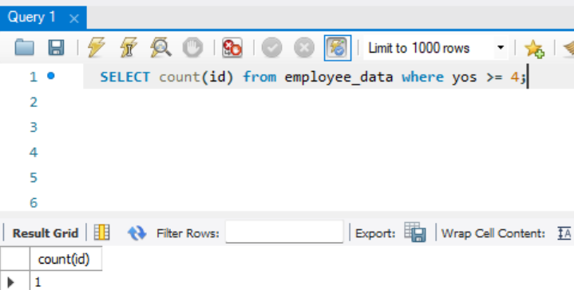
- Count employees based on their ages.
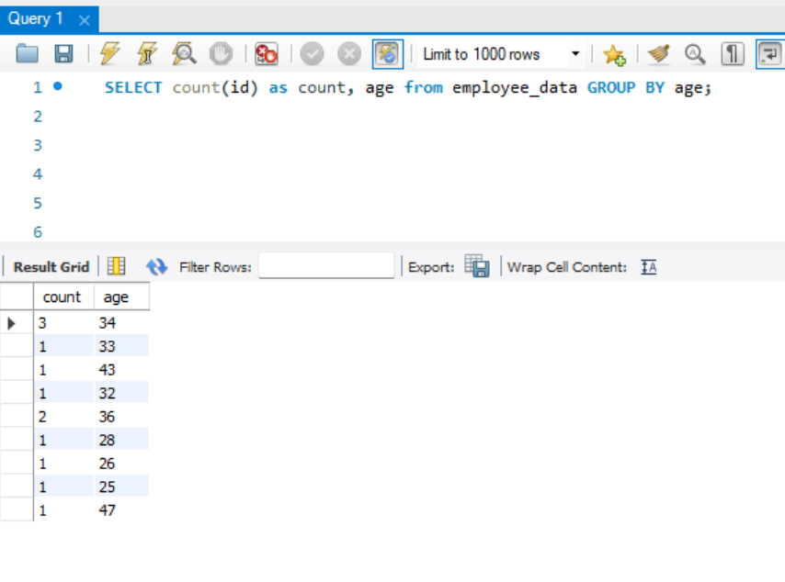
- Modify the above so that the ages are listed in a descending order.
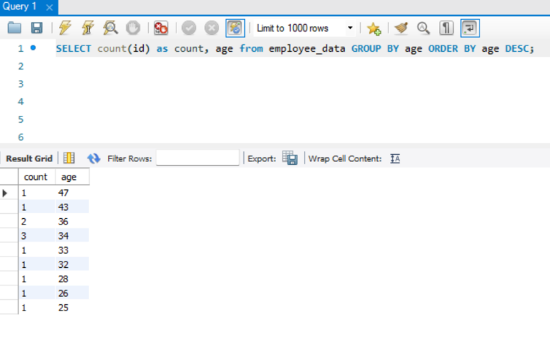
- Find the average age of employees in different departments (titles).
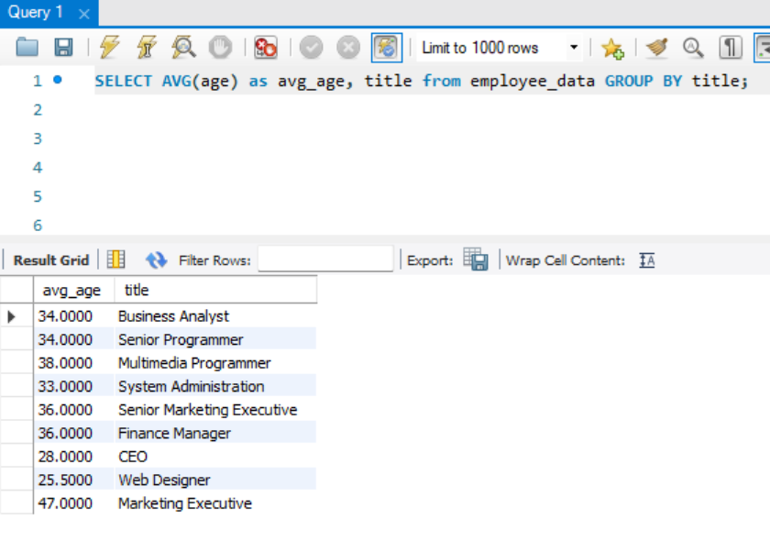
- Change the above statement so that the data is displayed in a descending order of average ages.
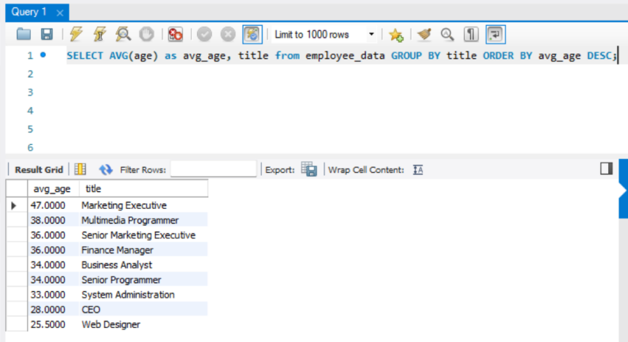
- Find and list the percentage perk 9perk/salary x 100 for each employee with the 5 perks sorted in a descending order.
